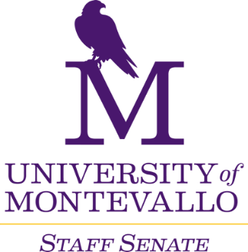

**Thursday, October 3, 2024**

**Merrill Room**

**10 a.m.-12 p.m.**

**AGENDA**

1. Welcome
2. Approval of minutes
3. TogetherUM campaign - Jamaica Dunigan
4. Old Business
   1. Staff Salary Policy draft – final thoughts and vote
   2. Staff Performance Evaluations
   3. Staff Senate VP Decision
   4. Finalize goals for the year
5. New Business
   1. BOT Retreat
6. Reports from Departments
   1. Updates?
7. Next Meeting
   1. November 7, 2024